PA B2-5: SORTING
TOPIC
B2
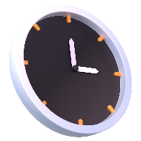
TIME TO COMPLETE: 2 HOURS

Write your responses to parts 2 and 4 in a word document. Make sure to include your name and the programming assignment number. Your code can be uploaded alongside the accompanying word document.

PART 1: PROBLEM STATEMENT
You’re in man! I can’t believe that we got you to infiltrate MetaCritic HQ! We’re gonna have to act fast to make sure that we aren’t spotted and that we can change the review score of our new movie!
Basically, we need you to write a program that will take in an unlimited number of user input reviews. These will be formatted with the review score between 0 and 10 (including decimal values), then a comma, then the rest of the review. You can expect reviews to look something like this:
7.8, Too much water
3.2, There was not enough water
6, I thought I was going to watch The Boss Baby but this was better
Now, because you’re our inside man, we want you to get rid of any reviews that are less than a 5 to help our review score, and print out the average score with those values removed. Then, we want you to sort the remaining reviews from worst to best and print out the reviews (in order) for any review that gave a 7 or above. We’re counting on you, don’t let us down!

PART 2: BRAINSTORMING THE ALGORITHM
- What data structures will you use in the creation of this program, and what purpose do they serve? [5]
- How do you plan to modify the input to get it to a sortable state? [10]

- Outline the structure of your program in broad overall terms, explaining your logic. [10]

PART 3: WRITE THE PROGRAM
Write your code in a .py file using no dependencies (using other libraries or programs). Feel free to use the IDE of your preference, but ensure you only upload the .py file (alongside the answers to the questions in this document).
Your program will need to take input for as many reviews as the user would like to enter. You may assume these reviews contain no commas other than the first comma separating the score from the text of the review.
Ensure that your submission adheres to the FIVE LAWS OF CODECRAFT.
Example output is provided below.
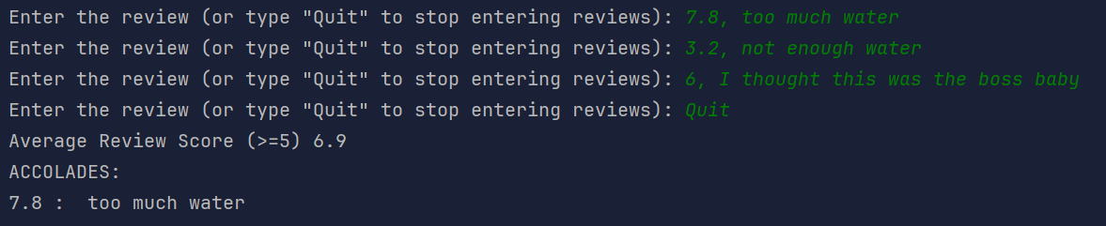
Upload the .py file with your program to ManageBac. [5]
Ensure the reviews with scores over 7 are printed to the screen. [20]
Ensure the average of reviews with scores of 5 or over are printed to the screen. [15]
EXTRA CREDIT [+10% to any assignment you’d like]: Also sort the reviews that got 5 or below and print out both the three lowest reviews and three highest reviews within these categories.

PART 4: REFLECTION
Answer the following questions in the "Programming Assignment Documentation Template" that can be found in ManageBac.
- Did your final project match up with your idea from the brainstorming phase? If not, what changed? [5]

- Are there any known bugs in your program that you could not address? Elaborate. [5]

- How did you manage sorting by the review score while maintaining the review’s text? [10]

- List the values that you tested the program with and explain why you chose those inputs. You should use at least 3 sets of input values. [10]

- List any sources used in the creation of your program and how you used them. [5]

